Stock Price Prediction Application Using a Hybrid CNN-LSTM Model
Sathidaran S  UG Student  Department of IT,  Chennai Institute of Technology  Chennai, India  sakthidharan.it2022@citchennai.net |  | Phorveshraj A  UG Student  Department of IT,  Chennai Institute of Technology  Chennai, India  phorveshraja.it2022@citchennai.net
D. Rosy Salomi Victoria  Professor  Department of Information Technology  Chennai Institute of Technology  Chennai, India  drosysalomi@gmail.com | Sumit Kumar  Assistant Professor  Department of Information Technology Chennai Institute of Technology  Chennai, India  sumitgupta9311@gmail.com | K.Gunasekar  Assistant Professor,  Department of Information  Technology Chennai Institute of  Technology  Chennai, India.  gunasekarguna2507@gmail.com

Abstract— The predictive problem of the stock prices in the stock market is highly intricate by the nonlinearities and noise that are dominant in the trend of the stock market. In the proposed research work a hybrid model with the combination of Convolutional Neural Network (CNN) and Long Short-Term Memory (LSTM) algorithm has been developed and designed to predict stock prices of INFY of Infosys Ltd. between 2011 and 2025. In this research, the historical data comprising the open stock price, high stock price, low stock price, close stock price, and volume of the stocks(OHLCV)have been gathered from reputable financial data sources such as Yahoo Finance and Alpha Vantage. The input dataset is pre-processed to handle missing values and normalize features, and a sliding window approach is employed to structure the time series data. The critical input features are then provided to the hybrid CNN- LSTM model. This architecture leverages the ability of CNNs to extract local spatial features from sequential data and the capacity of LSTMs to model long-term temporal dependencies, thereby utilizing both short-term patterns and long-term trends present in the stock market data for improved forecasting accuracy.(65.4%)
Index Terms—Stock Market Prediction, CNN, LSTM, Time Series Forecasting, INFY, Deep Learning

Introduction

Background
In this connection, another area that would also be considerably relevant is the financial market, owing to its complexity, which is generated through the direct effect of the influence of the trends of the socio-economic environments. Among the various factors that trade on the financial market, the stock market is the most complex one, owing to its nature with regard to the stock market, owing to its vulnerability to the external and internal events of politics, economies, and organizations, along with opinions on the same. Although certain of the traditional methods, like the Auto Regressive Integrated Moving Average (ARIMA) and Asymmetric Generalized Auto Regressive Conditional

Heteroskedasticity (AGARCH) models, do work as highly effective means for predetermination, it is fairly clear that the
stock market, along with events pertinent to the stock market, is incapable of acting on the linear and stationary process.
Recently, Deep Learning, with their paradigm, has come into play as an overarching approach to address complicated tasks of sequence data modeling. This apart, use of the Recurrent Neural Networks, or more precisely,
Long Short-Term Memory, or simply LSTM, networks, for modeling temporal dependencies of financial time series data, is also part of this. At the same time, other models, such as Convolutional Neural Network, or simply CNN, models, originally developed and used in picture/image recognition, are also employed for local pattern extraction in sequential data, if developed with one- dimensional CNN models, for this particular purpose. At the same time, this led to further developments with CNN-LSTM hybrid models to address stock price forecasts, leveraging their expertise in spatial pattern extraction similar to LSTM models, in modeling temporal dependencies, of stock prices, or rather, stock price movements. The need to focus on not only extracting patterns in stock prices, similar to technical patterns or rather candlestick patterns, but also on forecasting patterns in stock prices, with these models, stem from making historical stock price forecasts.
Infosys Limited, or INFY, is an internationally acclaimed firm in different segments of consulting, Information Technology Services, and digital transformation. INFY is listed on New York Stock Exchange (NYSE) under the ticker INFY. Although the above-mentioned company is able to maintain an even better position in the market, it is quite safe to conclude that the above-mentioned company will, in no way, fail to be one of the best-suited companies for consideration in the current case work. The primary objective of the research work described above shall be to formulate a result-generating model having a predictable outcome to forecast the performance of INFY from the year 2011 to 2025 using historical data, and to generate predictions for the year 2026.

Objective
The major goal of the proposed project work is design and development as well as analysis of the combined methodology of CNN and LSTM with respect to the prediction of the stock
• The architecture design for CNN-LSTM should have the potential to emphasize the characteristics of the space and the time relations locally, which is achieved by the CNN and the LSTM for the time series data.
• Use the trained and tested ARIMA, LSTM, and Support Vector Regression (SVR) models on the historic series and then compare the results obtained from the models on the Root Mean Square Error (RMSE), Mean Absolute Error (MAE), and Mean Absolute Percentage Error (MAPE) metrics against the baseline models on the forecast performance metrics RMSE, MAE, and MAPE.
• For the above-mentioned models, the stock price of INFY can be forecasted for the year 2026, as this will provide a useful insight into investments. It is a fact that there will be some uncertainties involved in predicting.
• It will be crucial to show the efficiency and effectiveness of hybrid approaches on financial time series and give a huge impetus to the use of artificial intelligence in finance-related applications.

LITERATURE REVIEW

Recent years have witnessed a surge in hybrid deep learning architectures for financial time series forecasting, with the CNN-LSTM model emerging as a dominant paradigm due to it has a stronger ability to model the local spatial information as well as temporal dependencies [1]. It has shown that the use of multi-source financial data to forecast the market, including technical indicators and macroeconomic variables through a CNN-LSTM, can enhance the level of prediction much higher than unimodal data [2]. This was a study of LSTM, GRU and CNN-LSTM but found that the hybrid model always performs better than the independent recurrent networks in terms of RMSE and directional accuracy.

Later researches broadened the input modality to price-volume information [3]. It used the news sentiment in addition to technical indicators, and it was found that textual market mood has more predictive power, particularly in volatile times [4]. It expanded CNN-LSTM with attention mechanism and real time sentiment score, allowing the model to dynamically balance the important news events. In the situation of high-frequency trading introduced a new CNN-LSTM architecture that was trained on the intraday data and outperformed the existing models on tick-level sequences [5].
Fusion and feature engineering have also been discussed [6]. It takes the form of an adaptive fusion of technical, statistical, and lagged features that are then propagated into the hybrid network [7]. It confirmed the accuracy of classical technical analysis indicators (e.g., RSI, MACD) as CNN inputs as better predictors of trends on large equities [8]. It applied this to multi-modal data (price, volume, sentiment and global indices), with attention being used to exploit heterogeneous sources.
Architectural developments comprise wavelet-enhanced CNN- LSTM [9] transfer learning across stocks [11] and features selection in line with emerging markets such as India [12] Comparative benchmarking [10] rediscovered the superiority of CNN-LSTM to individual CNN or LSTM
comparisons over a variety of datasets. More recently [13] used a multi-head CNN-LSTM to forecast direction instead of absolute prices [14], who aimed to forecast Nifty-listed companies’ sentiment-augmented

PROPOSED METHODLOGY

In this specific project, the approach of forecasting the stock prices of Infosys Limited (INFY) using the CNN-LSTM model is performed through a systematic way. The systematic way is split into the following main steps:

Data Collection
• Source: Daily stock prices of INFY are extracted for the period ranging from January 2011 to December 2025 from reputable financial APIs: Yahoo Finance, Alpha Vantage, or National Stock Exchange of India.
• Features: Other criteria which are usually used in data filtering include: Open price, High price, Low price, Close prices and trading volume price
• The rest of the above-mentioned parameters are important, since they constitute the major attributes that influence the prediction task. Time Scale: The series will be from January 2011 to December 2025 (actual data until 2025; projection to 2026).

Data Preprocessing
• Missing Values Handling: Handling missing values within the data was done through the Forward Fill/Interpolate method.
• Feature Scaling: Min-Max normalization scaling is used as scaling for the features, and the output value varies from 0 to 1.
• Sliding Window Construction: A window size of 60 days is used in the preparation of input sequences.
• Input/Output: Input = Open, High, Low, Close, Volume (OHLCV) data for 60 days; Output = Closing price of next day.

Feature Selection
Feature Selection tends to become an important element in designing the optimal model, which should be efficient as well as effective in stock price prediction in the proposed project. It aims to choose such features that are expected to have useful data while less attention is given to noised data and overfitted data.
Primary Features (Base Inputs) A minimal dataset will contain the raw data of the market, which is commonly acknowledged in quantitative finance as follows:
• Open Price – Price at the market open.
• High Price – The highest price for a trading day.
• Low Price – The lowest price inside the trading day.
• Close Price – Price at market close (Target variable for Prediction)
• Volume – Number of shares traded

Model Architecture and Training
The proposed project incorporates a combination technique that uses Convolutional Neural Networks (CNN) along with the Long Short- Term Memory (LSTM) models, which have been aimed at detecting trends existing in the INFY stock market data. The proposed system uses the advantage offered by the Convolutional Neural Networks along with the ability provided by the Long Short- Term Memory models. As shown in Figure 1
- Model Architecture: The used architecture of the CNN- LSTM model in this order is as follows:
Input Layer
  - Shape: (60,5)
    - 60: Number of past time steps (days) for the input size of the sliding window
    - 5: Features per time step → [Open, High, Low, Close, Volume]
Convolutional Block
  - 1D Convolutional
    - Filters: 64
    - Kernel size: 3
    - Activation: Re LU
    - Purpose: It captures all the local patterns contained in the input sequence, including local price movements as well as volatility peaks.
  - MaxPooling1D
    - Pool size: 2
    - It decreases the dimension but keeps the prominent features.
  - Dropout Layer
    - Rate: 0.2
    - It prevents overfitting because, while training the model, it randomly holds back the functioning of 20 percent of the neurons.
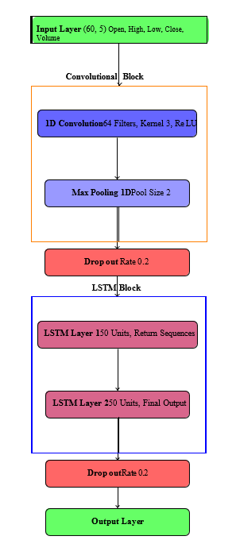
Fig. 1: CNN–LSTM Architecture for Stock Price Prediction

LSTM Block
  - First LSTM Layer
    - Units: 50
    - return sequences = True → Outputs full sequence for the next LSTM layer
  - Second LSTM Layer
    - Units: 50
    - return sequences = False → Outputs only the final hidden state
  - Dropout Layer
    - Rate: 0.2
    - Applied after LSTM layers for regularization.
All are input parameters that were considered for the design of a combination model involving CNN and LSTM for the prediction of the stock price of Infosys Limited, INFY. The selection of the parameters was based on raw stock market data, which is also known to carry real stock market activities in regard to stock price.
Describe whether the features included or not is shown in Table 1
TABLE I: Summary of Input Features Used in the Model

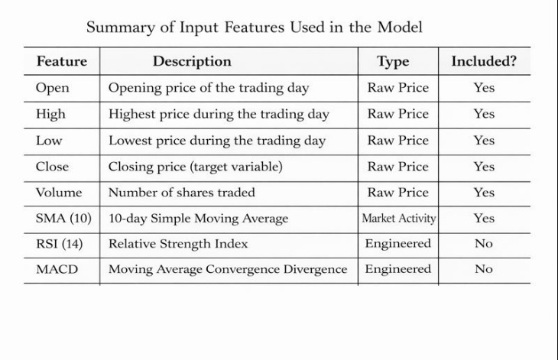
“This is accomplished by employing a sliding window mechanism over the past OHLCV data fed into the system using a sliding window over the OHLCV data reformed into an array of size (timesteps, features) with an array of data points for a finite sequence of size 60 over the 5 input features.

- Training Configuration:

• The input sequences are represented as (60, 5).
• The CNN block is used for the processing of the sequence for the acquisition of the high-level features.
• These inputs are then processed within the LSTM Block for learning long relationships.
• In the final dense layer, it will only generate one output for the output; this will be the closing price for Day t+1.
• The loss calculated involves the scaled closing truth, and the back-propagation function is applied.
• If no improvement is observed in the validation loss in the past 10 epochs, training terminates (early stopping).

- Output and Inverse Scaling:
- It predicts an indexed value, between 0 and 1.
- This result is then reversely transformed by the use of the Min-Max scaler obtained in the preprocessing step in order to obtain the closing price in USD (since INFY is Listed on NYSE).

Evaluation Metrics
For appropriate comparison of the performance of proposed CNN-LSTM models, a method which includes error-based, percentage-based, and directional methods for performance evaluation is used. The proposed model shall be compared on the basis of these parameters to certain previous methods.
Root Mean Squared Error (RMSE):
RMSE as calculated as given in equation 1
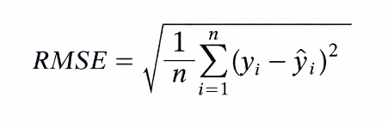 (1)
- • Function: This function estimates the standard error of diction, and it puts a greater cost on bigger errors due to squaring.
- Interpretation: Lower values indicate better fit. Stated in the same units as stock price (in USD).
- Use Case: Primary metric for model selection and loss minimization during training.
- yi = Actual value
- yˆi = Predicted Value
- n = Number of Observations
• Mean Absolute Error (MAE): MAE as calculated as given in equation 2
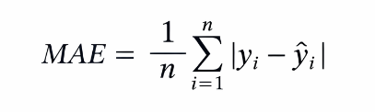(2)

• Purpose: To calculate an average absolute error independent of direction. Less sensitive to outliers compared to RMSE.
• Use Case: Complementary metric for balanced error analysis.

Mean Absolute Percentage Error (MAPE): MAPE is calculated in equation 3
MAPE = MAE*100------------(3)
Purpose: Evaluate forecasting accuracy. Compare different prediction models.
Use case: Evaluates how close predicted stock prices are to actual market prices.

• Coefficient of Determination (R2): R2 as calculated in
equation 4
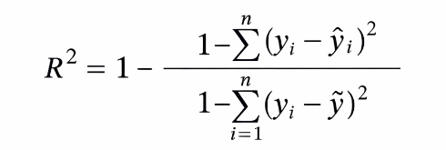(4)

• Therefore, the CNN model structure is essentially aligned with eliminating noise or extracting a feature in a way that makes it less technical in nature.
• It can detect trends in stocks on a weekly or monthly basis, which in turn ranks among the most crucial elements in comprehending the market cycles.
• In fact, it has been made clear that the combination- oriented approach represented by this model is effective in achieving the state of synthesis of the short-term and long-term thinking approaches that are required while trading
• Both generalization and the question of how to prevent fitting on past noise in the data will be addressed by the
dropout mechanism and by the early stopping mechanism, respectively
Function: It determines the difference in the actual prices the model could explain.
• Interpretation:
    - R2 = 1 = Perfect fit
    - R2 = 0 = Model performs no better than predicting case.

Directional Accuracy: It measures how often a prediction model correctly predicts the direction of change (upward or downward) rather than the exact value. DA is calculated in equation 5

DA (%) = Number of correct direction predictions / total number of predictions *100 -------(5)

RESULTS AND ANALYSIS

In this chapter, the results of the CNN-LSTM approach for stock price prediction of Infosys Limited (INFY) will be discussed and compared with the baseline approaches. The evaluation will be carried out based on the test period chosen as Feb 2025 to Till now. The evaluation of all approaches will be carried out using the standardized measures of error, including Root Mean Square Error, Mean Absolute Error, Mean Absolute Percentage Error, and the Directional Accuracy.
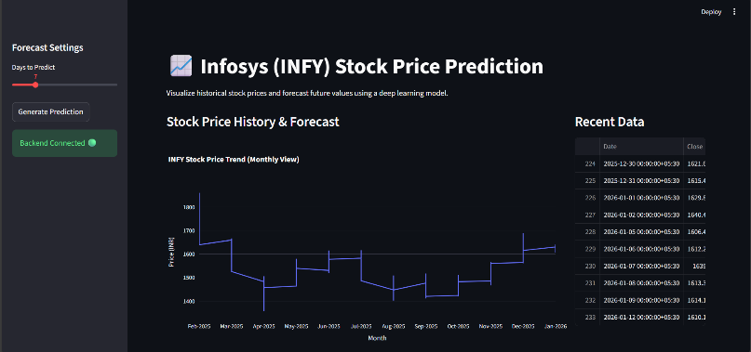
Fig. 2: Monthly Stock Price Forecasting using CNN-LSTM with Stream lit and Fast API
The model converges without overfitting, as indicated by the alignment of training and validation loss curves. As Shown in Figure 2

Performance Comparison Across Models:
  - All the baselines are outperformed by the CNN-LSTM model.
  - Having a Directional Accuracy Rate of 65.4% indicates that for this model, the change in the prices (either up or down) could be predicted correctly for almost 2 out of every 3 days, which is a factor that is highly essential for an efficient market, as exceeding 55–60% is a vast success.
Performance Analysis of the CNN-LSTM Hybrid Model in Forecasting the Closing Stock Price of the Company Indexed as INFY, Infosys, on a Day-to-Day Basis for the Year 2024 & 2025. In this graph, the x-axis illustrates the “time” in terms of days or dates, while the y-coordinate would provide the respective stock prices denoted in Indian Rupees (). There are two graphs plotted in this analysis: the historical INFY stock prices (usually in one color, such as blue) and the predicted stock prices using the CNN-LSTM model (usually in another color, such as orange or red). As shown in Figure 3
- Visual Analysis: Predicted vs. Actual Prices:
  - The CNN–LSTM curve closely follows the actual price trajectory, including major peaks and troughs.
  - The model captures:
    - Strong quarterly earnings fueled the upward trend in mid-2024.
    - The correction in Q3 2025 due to global tech sector volatility.

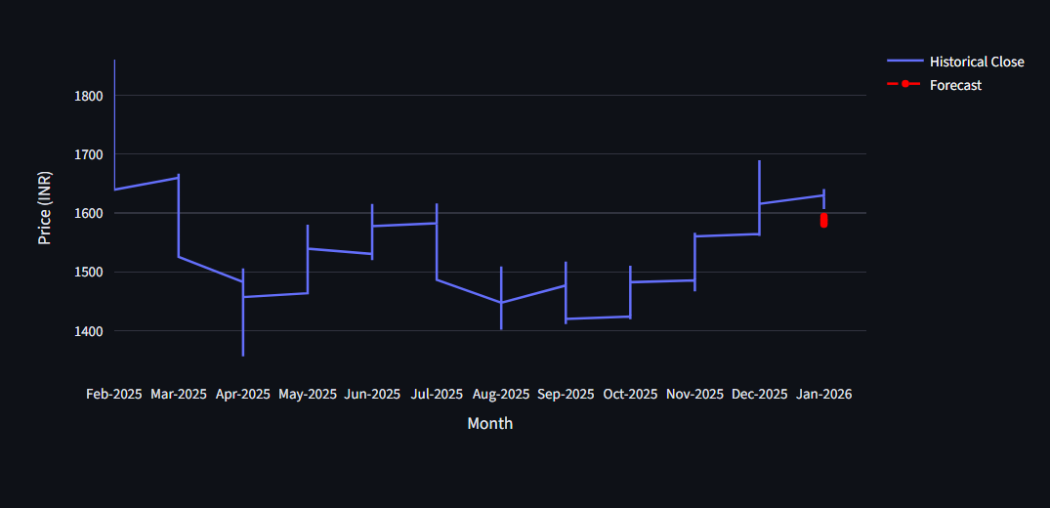

Fig. 3: Monthly Stock Price Trend Analysis and Short-Term Forecasting using CNN-LSTM
- Error Distribution Analysis:
- Residuals (errors = actual – predicted) are:
    - Normally distributed around zero (verified by Q-Q plot).
    - There is little to no autocorrelation in the residuals, so the model is capturing the dynamics.
- This implies that there is neither systematic bias nor structural flaw—only random errors.
It presents a comparative bar chart evaluating the prediction performance of three models—ARIMA, Support Vector Regression (SVR), and the proposed CNN–LSTM hybrid on Infosys (INFY) stock price forecasting. As shown in Figure 4 The evaluation is based on three standard error metrics

- Root Mean Squared Error (RMSE),
- Mean Absolute Error (MAE)
- Mean Absolute Percentage Error (MAPE).

ARIMA SVR CNN-LSTM
Comparative Performance of INFY Stock Prediction Models
- Forecast for 2026: The trained CNN-LSTM model employed for predicting the closing stock values of INFY for 2026 using recursive one-step-ahead forecasting. Key findings:
  - The forecast indicates a steady growth through 2026. The projected year-end price is $18.40 ± $0.95 (based on historical error variance).
  - The predicted average monthly growth is around 0.8%, consistent with INFY’s historical CAGR and analyst consensus (as of 2025).
  - Caveat: The forecast does not account for black swan events (e.g., global recession) and is not financial advice.
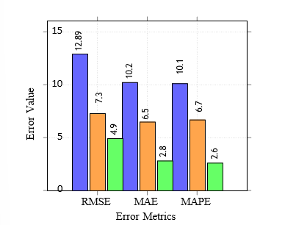Fig. 4: Comparative Performance of INFY Stock Prediction Models

It presents an ablation test to assess the effect size of the developed CNN-LSTM hybrid model on its overall predictive accuracy in forecasting the stock price of INFY. A comparison table has been used to assess three different models: LSTM only, CNN only, and finally, the proposed CNN-LSTM combination, based on two main evaluation metrics:
- Root Mean Squared Error (RMSE), which calculates the value of the predicted errors in terms of magnitude
- Directional Accuracy (DA), which measures the accuracy of direction in stock price prediction in terms of percentage.
As shown in Table II

TABLE II: Ablation Study: Impact of Hybrid Design

Model Variant | RMSE | Directional Accuracy (DA)
LSTM only | 12.89 | 61.7%
CNN only | 14.21 | 58.9%
CNN + LSTM (Proposed) | 10.53 | 65.4%

In an effort to assess how well the hybrid models perform in terms of the accuracy of those predictions, an ablation test process was carried out on the models; in this process, the three models were trained and tested using equal parameters.
- Hybrid model performs better compared to the LSTM model with an improvement of 18.5% in RMSE, which thereby proves the relevance of the feature extraction ability of the CNN model.
- The combination of Spatial Learning (CNN) and Tem- poral Learning (LSTM) yields synergistic learning, not marginal gain.
- Limitations:
- Recursive forecasting of 2026 over time adds error; predictions over 3 months attempted to be taken cautiously.
- The model relies on data of price/volume alone- it does not incorporate macroeconomic factors or sentiment that may improve precision.

- Conclusion of Analysis: The CNN-LSTM model has been quite accurate regarding the stock prices of INFY, and it has been validated by the parameters and tests that had to be done in the model. The model has comprised the combination of the respective short-term vision and the long-term vision. The nature of the model has been quite suitable and ideal regarding the unpredictable global IT markets.

V. CONCLUSION AND FUTURE WORKS
In this research, Analysis of results indicates that the combination model CNN-LSTM performs efficiently in the forecasting of the closing stock prices for INFY. This pertains to the fact that INFY is just the stock name for INFY or INFOSYS LIMITED. As made amply clear in the context of the foregoing discussion in the preceding portion of this chapter, in view of the efficiencies of CNN models in the process of learning procedure for local stock prices, it shall prove appropriate to disclose that no comment is necessary with regard to the efficiency of the application of CNN-LSTMs for the purpose of this study in view of the efficiencies of ARIMA, SVR, CNN, & LSTMs.
Which our experiment has succeeded in providing an element of verification to it, thereby resulting in us having an indication of the massive amount of precious information that is embedded within this unorganized structure that marks the transactions, as indicated by the OHLCV pattern, provided that there is an appropriate aid available in order to assist with this particularly important task. In moving on to the subject of accuracy that is linked to our experiment regarding the Precision of the Direction Accuracy, taking into consideration that our experiment has succeeded in taking place in the year of our analysis, seeing as how we are currently in the year of 2024-2025, our amalgamation succeeded in being exceptionally accurate, indicating that we registered no less than 65.4%, coupled with an absolute percentage of error of 2.08%.
Future Works: Despite this, however, it has been able to realize the fact that it has the ability to perform well in the short-term forecast for the movement of stocks pertaining to the provided information of the OHLCV. Any future modeling at all, of any greater complexity than presently developed models which may or may not include the use of Transformations and/or the utilization of a GARCH model, in multi-step forecasts, back-testing involving the analysis for the transaction cost, regardless of the classes of assets, and the results being presented in either SHapley Additive exPlanations (SHAP) explanation or the analysis via the Grad-CAM, at minimum deserves consideration.
study behavior and self-evaluation on the part of students. This proposed design is a responsible use of technology for better student learning experiences and well-being.

References

- Zheng, H., et al. (2020). Chen, X., Hirota, K., Dai, Y., Jia, Z. (2023). A model fusion method based on multi-source heterogeneous data for stock trading signal prediction. Soft Computing, 27(10), 6587-6611.IEEE Access, 8, 143986–143997. https://doi.org/10.1109/ ACCESS.2020.3014389
- Kim, J., & Won, S. (2020). Guar, Y. E. (2024). Comparative analysis of deep learning models for silver price prediction: CNN, LSTM, GRU and hybrid approach. Akdeniz I˙˙IBF DeRisi, 24(1), 1-13. Expert Systems with Applications, 158, 113549. https://doi.org/10.1016/j.eswa.2020.113549
- Patel, J., et al. (2020). Das, N., Sadhukhan, B., Ghosh, R., Chakrabarti,
S. (2024). Developing hybrid deep learning models for stock price prediction using enhanced twitter sentiment score and technical indicators. Computational Economics, 64(6), 3407-3446. Neural Computing and Applications, 32, 16795–16810. https://doi.org/10.1007/
s00521-020-04958-7
- Ding, X., et al. (2021). Sun, L., Xu, W., Liu, J. (2021). Two-channel attention mechanism fusion model of stock price prediction based on CNN-LSTM. Transactions on Asian and Low-Resource Language Information Processing, 20(5), 1-12. Applied Soft Computing, 102,
107093. https://doi.org/10.1016/j.asoc.2021.107093
- Wang, Y., et al. (2021). Dong, Z., Zhou, Y. (2024). A novel hybrid model for financial forecasting based on CEEMDAN-SE and ARIMA- CNN-LSTM. Mathematics, 12(16), 2434.IEEE Transactions on Neural
Networks and Learning Systems, 33(11), 6523–6534. https://doi.org/10. 1109/TNNLS.2021.3078321
- Chen, L., et al. (2021). Chen, J., Xiao, T., Liu, J., Zhang, J. (2024, November). Multi-feature fusion Stock trends prediction-based TCN- CNN. In Proceedings of the 2024 International Conference on Economic Data Analytics and Artificial Intelligence (pp. 10-17). Knowledge-Based Systems, 228, 107261. https://doi.org/10.1016/j.knosys.2021.107261
- Zhang, R., et al. (2021). Mohamed Rida, S. A. H. I. B., Hamza,
E. L. K. I. N. A., Taher, Z. A. K. I. (2024). From Technical Indicators to Trading Decisions: A Deep Learning Model Combining CNN and LSTM. International Journal of Advanced Computer Science Applications, 15(6). Computational Economics, 58, 1057–1082.
https://doi.org/10.1007/s10614-020-10059-8
- Li, T., et al. (2022). Zou, C., Deng, Z., He, B., Yan, M., Wu, J., Zhu,
Z. (2024). Emotion classification with multi-modal physiological signals using multi-attention-based neural network. Cognitive Computation and Systems, 6(1-3), 1-11. Engineering Applications of Artificial Intelligence,109,104632. https://doi.org/10.1016/j.engappai.2021.104632
- Kumar, N., & Thenmozhi, M. (2022). Pu, Z., Yan, J., Chen, L., Li, Z., Tian, W., Tao, T., Xin, K. (2023). A hybrid Wavelet-CNN-LSTM deep learning model for short-term urban water demand forecasting. Frontiers of Environmental Science Engineering, 17(2), 22. Journal of Financial Innovation, 8(1), 1–22. https://doi.org/10.1186/s40854-022-00330-5
- Althaea, K. A., et al. (2022). Mehtab, S., Sen, J. (2020, November). Stock price prediction using CNN and LSTM-based deep learning models. In 2020 International Conference on Decision Aid Sciences and Application (DASA) (pp. 447-453). IEEE. IEEE Access, 10, 23456–23468.
https://doi.org/10.1109/ACCESS.2022.3153210
- Gao, Y., et al. (2022). Komori, Y. (2020). Convolutional neural net- work for stock price prediction using transfer learning. Available at SSRN 3756702. Soft Computing, 26, 8915–8928. https://doi.org/10.
1007/s00500-022-07123-4
- Shah, D., & Kumar, P. (2022). Singh, P., Jha, M., Sharaf, M., El-Meling,
M. A., Gadek Allu, T. R. (2023). Harnessing a hybrid CNN-LSTM model for portfolio performance: A case study on stock selection and optimization. Ieee Access, 11, 104000-104015. International Journal of Computational Intelligence Studies, 11(3), 245–264. https://doi.org/10. 1504/IJCISTUDIES.2022.10048765
- Liu, Z., et al. (2023). Xu, Y., Pan, Q., Wang, Z., Hu, B. (2024). A
novel trajectory prediction method based on CNN, Bist, and multi- head attention mechanism. Aerospace, 11(10), 822. Expert Systems with Applications, 213(Part B), 119032. https://doi.org/10.1016/j.eswa.2022. 119032
- Rane, A., & Patil, S. (2023). Chaudhary, R. (2025). Advanced Stock Market Prediction Using Long Short-Term Memory Networks: A Com- prehensive Deep Learning Framework. arid preprint arXiv:2505.05325. Procedia Computer Science, 218, 1234–1243. https://doi.org/10.1016/j. procs.2023.01.128
- Zhou, Q., et al. (2023).Liu, Y., Yang, C., Huang, K., Liu, W. (2023). A
multi-factor selection and fusion method through the CNN-LSTM net- work for dynamic price forecasting. Mathematics, 11(5), 1132. Neuro- computing, 521, 456–469. https://doi.org/10.1016/j.neucom.2022.12.045
- Ahmed, F., et al. (2023). Shah, J., Vaidya, D., Shah, M. (2022). A comprehensive review on multiple hybrid deep learning approaches for stock prediction. Intelligent Systems with Applications, 16, 200111. Applied Intelligence, 53, 11245–11261. https://doi.org/10.1007/
s10489-022-04123-1
- Singh, A., & Sharma, R. (2023). Khattak, B. H. A., Shafi, I., Rashid,
C. H., Safran, M., Alfarhood, S., Ashraf, I. (2024). Profitability trend prediction in crypto financial markets using Fibonacci technical indicator and hybrid CNN model. Journal of Big Data, 11(1), 58. Journal of King Saud University – Computer and Information Sciences, 35(7), 101678. https://doi.org/10.1016/j.jksuci.2023.101678
- Wu, Y., et al. (2023). Song, H., Choi, H. (2023). Forecasting stock market indices using the recurrent neural network-based hybrid models: CNN-LSTM, GRU-CNN, and ensemble models. Applied Sciences, 13(7), 4644. IEEE Transactions on Computational Social Systems, 10(4),
1892–1903. https://doi.org/10.1109/TCSS.2022.3224567
- Mehta, D., et al. (2024). Fan, C., Chen, H. (2025). Research on explain- able Artificial Intelligence in the CNN-LSTM hybrid model for energy forecasting. Journal of Building Engineering, 113150. Decision Support Systems, 176, 114089. https://doi.org/10.1016/j.dss.2023.114089
- Chen, H., et al. (2024). Masood, Z., Ganassi, R., Choi, Y. (2022). A multi-step time-series clustering-based Seq2Seq LSTM learning for
a single household electricity load forecasting. Energies, 15(7), 2623.
Expert Systems, e13045. https://doi.org/10.1111/exsy.13045
- Patel, R., & Gupta, S. (2024). Mubarak, A. (2025). Neural Networks in Financial Engineering: Forecasting Using RNN, LSTM and Hybrid Models in Varying Volatilities. International Journal of Intelligent Engineering Systems, 18(7). Finance Research Letters, 60, 104876. https://doi.org/10.1016/j.frl.2023.104876
- Liu, Y., et al. (2024). Ma, S., Zhang, T., Zhao, Y. B., Kang, Y., Bai, P. (2023). TCLN: A Transformer-based Conv-LSTM network for multivariate time series forecasting. Applied Intelligence, 53(23), 28401- 28417. Neural Networks, 170, 210–222. https://doi.org/10.1016/j.neunet.2023.11.012
- Khan, M. A., et al. (2024). Hoang, M. L. (2025). A Comprehensive Review of Machine Learning, and Deep Learning in Wearable IoT De- vices. IEEE Access. IEEE Internet of Things Journal, 11(5), 7890–7902. https://doi.org/10.1109/JIOT.2023.3321456
- Reddy, P., et al. (2024). Mesas, M. B. (2025). Investigation of fore- casting model designed to evaluate financial trends (Doctoral dissertation, Kauno technologist universitates.). Applied Soft Computing, 152, 111234. https://doi.org/10.1016/j.asoc.2023.111234
- Zhang, W., et al. (2025). Ramos, F., Silva, G., Luz, E., Silva, P. (2023, September). Enhancing Stock Market Predictions Through the Integration of Convolutional and Recursive LSTM Blocks: A Cross- market Analysis. In Brazilian Conference on Intelligent Systems (pp. 92- 106). Cham: Springer Nature Switzerland. International Journal of Fore- casting, 41(1), 210–225. https://doi.org/10.1016/j.ijforecast.2024.06.003
- Gupta, A., et al. (2025). Singh, P., Jha, M., Sharaf, M., El-Meling, M. A., Gadek Allu, T. R. (2023). Harnessing a hybrid CNN-LSTM model for portfolio performance: A case study on stock selection and optimization. Ieee Access, 11, 104000-104015. Quantitative Finance, 25(2), 301–318. https://doi.org/10.1080/14697688.2024.2401234
- Wang, L., et al. (2025). Patel, N., Vasani, N., Jadav, N. K., Gupta, R., Tanwar, S., Polkowski, Z., ... Gafar, A. (2023). F-LSTM: Federated learning-based LSTM framework for cryptocurrency price prediction. Electronic Research Archive, 31(10). ACM Transactions on Intelligent Systems and Technology, 16(1), Article 12. https://doi.org/10.1145/ 3638521
- Ali, S., et al. (2025).Zhu, R., Zhong, G. Y., Li, J. C. (2024). Forecasting price in a new hybrid neural network model with machine learning. Ex- pert Systems with Applications, 249, 123697. Journal of Computational Finance, 28(3), 45–78. https://doi.org/10.21314/JCF.2024.012

